

**YEAR: 8**

**2016**

**SUBJECT: Science**

**Test: Microscopes**

**TIME: 60 minutes**

**QUESTIONS: Section A: 12 Multiple Choice (12marks)**

**Section B: 5 Short Answer (22 marks)**

**Section C: 1 Long Answer (10 marks)**

**TOTAL MARKS: 44 marks**

**PLEASE DO NOT WRITE ON THIS BOOKLET**

**SECTION A. Multiple Choice Questions**  
*This section has 20 questions. Answer all questions on the separate multiple-choice answer sheet provided.*

1. At school, what is the name of the equipment used to look at cells?
2. stereoscope
3. electron microscope
4. telescope
5. light microscope
6. The magnification of the microscope tells you

a) how big the lenses in the microscope are

b) how much smaller the image is than the real object

c) how much bigger the image is than the real object

d) how much light is passing through the object

1. Which of the following is the smallest unit of length?

a) Meters

b) Kilometers

c) Millimeters

d) Centimeters

1. A micrometre (μm) is:

a) one-thousandth of a millimetre   
b) one-hundredth of a millimetre   
c) one-thousandth of a centimetre  
d) one-hundredth of a centimetre

1. As the magnification increases, then the field of view

a) gets smaller

b) gets bigger

c) stays the same

d) doubles in size

1. When looking through a microscope, if you move the slide to the right, the specimen appears to move to the
2. right
3. up
4. left
5. down
6. When carrying a microscope, what is the safest part to hold?
7. stage
8. arm
9. mirror
10. tube
11. Which of the following is **NOT** a part of animal cells?
12. nucleus
13. cell wall
14. cytoplasm
15. cell membrane
16. What is the definition of a unicellular organism?
17. a living thing
18. a single celled living thing
19. more than one cell living thing
20. a non-living thing
21. What is the purpose of the cell wall in plant cells?
22. allow nutrients in and out of the cell
23. hold the organelles of the cell
24. provide structure and support to the cell
25. allows the cell to photosynthesise
26. What does a plant cell have that a fungal cell does not?
27. cytoplasm
28. chloroplast
29. nuclear membrane
30. cell wall
31. Mitochondria, ribosomes, lysosomes and endoplasmic reticulum are examples of

a) organelles

b) chloroplast

c) muscles

d) nuclear membrane

**Safety Bay Senior High School**

**Science 8 – Microscope Test**

Name: _______________________________________________

Section A: Multiple Choice Answers

Put a cross (X) through the correct answer.

**1** a b c d

**2** a b c d

**3** a b c d

**4** a b c d

**5** a b c d

**6** a b c d

**7** a b c d

**8** a b c d

**9** a b c d

**10** a b c d

**11** a b c d

**12** a b c d

Marks

Section A: Section B: Section C:

Multiple Choice Short Answers Long Answer Total

/44

/22

/10

/12

Short Answer Section

1. Label and write a brief purpose of each part of the microscope.

(7 marks)

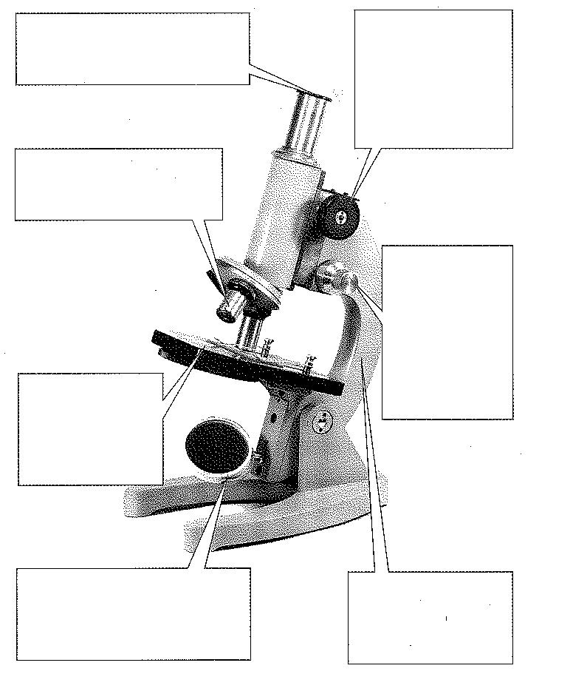

1. Complete the following: (4 marks)

a) Name the two parts that you would **hold** to carry the microscope safely

______________________________________________________________

b) Name the part you place the slide on  
  
______________________________________________________________

c) Name two microscope parts that magnify the slide  
  
______________________________________________________________  
  
d) Name two microscope parts that allows a slide to be focused  
______________________________________________________________

1. Use the diagram to complete the following questions



**A**

**B**

**C**

**D**

**E**

1. Match the organelle names with the correct letter from the cell diagram (5 marks) vacuole, mitochondria, nucleus, cell membrane, cytoplasm

|  |  |
| --- | --- |
| **Label** | **Organelle** |
| A |  |
| B |  |
| C |  |
| D |  |
| E |  |

1. Is the diagram of a plant or animal cell? Explain? (2 marks)

____________

1. With the aid of a diagram explain what would happen to the letter ‘e’ if viewed under a microscope (4 marks)

**SECTION THREE: Long Answer**

Explain fully how you would use a microscope when focusing on an object. Include all safety considerations in your answer. (10 marks)

______________________________

______________________________

______________________________

____________